**第一种：FORM身份验证（若在ASP.NET应用程序使用，则该验证方式不支持跨域，因为cookie无法跨域访问）**

1.定义一个FormAuthenticationFilterAttribute，该类继承自AuthorizationFilterAttribute，并重写其OnAuthorization，在该方法中添加从请求头中获取有无登录的Cookie，若有则表示登录成功，否则失败，代码如下：

[复制代码](javascript:void(0);)

using System;

using System.Collections.Generic;

using System.Linq;

using System.Web;

using System.Web.Http;

using System.Web.Http.Filters;

using System.Web.Security;

using System.Net.Http;

using System.Collections.ObjectModel;

using System.Net.Http.Headers;

using System.Threading;

using System.Security.Principal;

using System.Net;

using System.Text;

namespace WebApplication1.Models

{

public class FormAuthenticationFilterAttribute : AuthorizationFilterAttribute

{

private const string UnauthorizedMessage = "请求未授权，拒绝访问。";

public override void OnAuthorization(System.Web.Http.Controllers.HttpActionContext actionContext)

{

if (actionContext.ActionDescriptor.GetCustomAttributes<AllowAnonymousAttribute>().Count > 0)

{

base.OnAuthorization(actionContext);

return;

}

if (HttpContext.Current.User != null && HttpContext.Current.User.Identity.IsAuthenticated)

{

base.OnAuthorization(actionContext);

return;

}

var cookies = actionContext.Request.Headers.GetCookies();

if (cookies == null || cookies.Count < 1)

{

actionContext.Response = new HttpResponseMessage(HttpStatusCode.Unauthorized) { Content = new StringContent(UnauthorizedMessage, Encoding.UTF8) };

return;

}

FormsAuthenticationTicket ticket = GetTicket(cookies);

if (ticket == null)

{

actionContext.Response = new HttpResponseMessage(HttpStatusCode.Unauthorized) { Content = new StringContent(UnauthorizedMessage, Encoding.UTF8) };

return;

}

//这里可以对FormsAuthenticationTicket对象进行进一步验证

var principal = new GenericPrincipal(new FormsIdentity(ticket), null);

HttpContext.Current.User = principal;

Thread.CurrentPrincipal = principal;

base.OnAuthorization(actionContext);

}

private FormsAuthenticationTicket GetTicket(Collection<CookieHeaderValue> cookies)

{

FormsAuthenticationTicket ticket = null;

foreach (var item in cookies)

{

var cookie = item.Cookies.SingleOrDefault(c => c.Name == FormsAuthentication.FormsCookieName);

if (cookie != null)

{

ticket = FormsAuthentication.Decrypt(cookie.Value);

break;

}

}

return ticket;

}

}

}

[复制代码](javascript:void(0);)

2.在需要认证授权后才能访问的Controller中类或ACTION方法上添加上述授权过滤器FormAuthenticationFilterAttribute，也可在global文件中将该类添加到全局过滤器中，同时定义一个登录ACTION，用于登录入口，示例代码如下：

[复制代码](javascript:void(0);)

using System;

using System.Collections.Generic;

using System.Linq;

using System.Net;

using System.Net.Http;

using System.Web;

using System.Web.Http;

using System.Web.Security;

using WebApplication1.Models;

namespace WebApplication1.Controllers

{

[FormAuthenticationFilter]

public class TestController : ApiController

{

[AllowAnonymous]

[AcceptVerbs("Get")]

[Route("Api/Test/Login")]

public HttpResponseMessage Login(string uname, string pwd)

{

if ("admin".Equals(uname, StringComparison.OrdinalIgnoreCase) && "api.admin".Equals(pwd))

{

//创建票据

FormsAuthenticationTicket ticket = new FormsAuthenticationTicket(1, uname, DateTime.Now, DateTime.Now.AddMinutes(30), false, string.Empty);

//加密票据

string authTicket = FormsAuthentication.Encrypt(ticket);

//存储为cookie

HttpCookie cookie = new HttpCookie(FormsAuthentication.FormsCookieName, authTicket);

cookie.Path = FormsAuthentication.FormsCookiePath;

HttpContext.Current.Response.AppendCookie(cookie);

//或者

//FormsAuthentication.SetAuthCookie(uname, false, "/");

return Request.CreateResponse(HttpStatusCode.OK, "登录成功！");

}

else

{

HttpContext.Current.Response.AppendCookie(new HttpCookie(FormsAuthentication.FormsCookieName) { Expires = DateTime.Now.AddDays(-10) });//测试用：当登录失败时，清除可能存在的身份验证Cookie

return Request.CreateErrorResponse(HttpStatusCode.NotFound, "登录失败，无效的用户名或密码！");

}

}

// GET api/test

public IEnumerable<string> GetValues()

{

return new string[] { "value1", "value2" };

}

// GET api/test/5

public string GetValue(int id)

{

return "value";

}

}

}

[复制代码](javascript:void(0);)

测试用法一：可直接在浏览器中访问需要授权的方法（即：Login除外），如：http://localhost:11099/api/test/，响应结果如下：

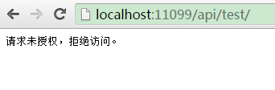

请求头信息如下：

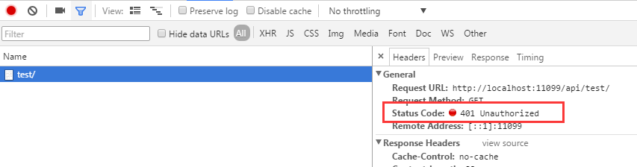

若成功调用Login方法后（http://localhost:11099/api/test/login?uname=admin&pwd=api.admin），再调用上述方法，则可以获得正常的结果，如下图示：

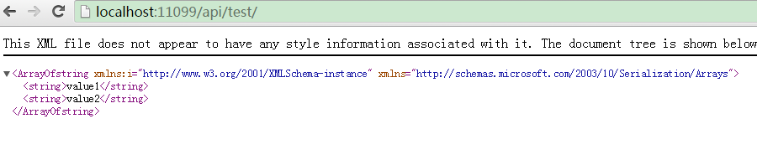

看一下请求时附带的Cookie，如下图示：

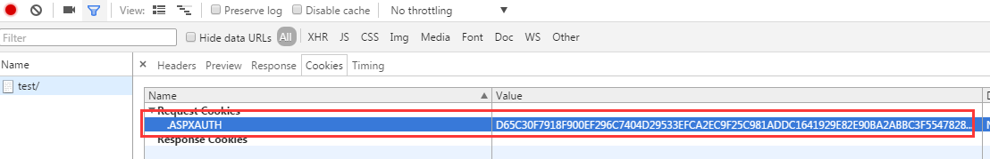

测试用法二：采用HttpClient来调用Api的相关方法，示例代码如下：

[复制代码](javascript:void(0);)

public async static void TestLoginApi()

{

HttpClientHandler handler = new HttpClientHandler();

handler.UseCookies = true;//因为采用Form验证，所以需要使用Cookie来记录身份登录信息

HttpClient client = new HttpClient(handler);

Console.WriteLine("Login>>>>>>>>>>>>>>>>>>>>>>>>>>>>>");

var response = await client.GetAsync("http://localhost:11099/api/test/login/?uname=admin&pwd=api.admin");

var r = await response.Content.ReadAsAsync<dynamic>();

Console.WriteLine("StatusCode:{0}", response.StatusCode);

if (!response.IsSuccessStatusCode)

{

Console.WriteLine("Msg:{1}", response.StatusCode, r.Message);

return;

}

Console.WriteLine("Msg:{1}", response.StatusCode, r);

var getCookies = handler.CookieContainer.GetCookies(new Uri("http://localhost:11099/"));

Console.WriteLine("获取到的cookie数量：" + getCookies.Count);

Console.WriteLine("获取到的cookie：");

for (int i = 0; i < getCookies.Count; i++)

{

Console.WriteLine(getCookies[i].Name + ":" + getCookies[i].Value);

}

Console.WriteLine("GetValues>>>>>>>>>>>>>>>>>>>>>>>>>>>>>");

response = await client.GetAsync("http://localhost:11099/api/test/");

var r2 = await response.Content.ReadAsAsync<IEnumerable<string>>();

foreach (string item in r2)

{

Console.WriteLine("GetValues - Item Value:{0}", item);

}

Console.WriteLine("GetValue>>>>>>>>>>>>>>>>>>>>>>>>>>>>>");

response = await client.GetAsync("http://localhost:11099/api/test/8");

var r3 = await response.Content.ReadAsAsync<string>();

Console.WriteLine("GetValue - Item Value:{0}", r3);

}

[复制代码](javascript:void(0);)

结果如下图示：

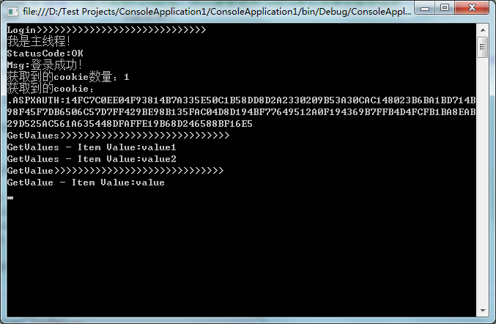

 如果Web Api作为ASP.NET 或MVC的一部份使用，那么完全可以采用基于默认的FORM身份验证授权特性（Authorize），或采用web.config中配置，这个很简单，就不作说明了，大家可以网上参考关于ASP.NET 或ASP.NET MVC的FORM身份验证。

**第二种：集成WINDOWS验证**

首先在WEB.CONFIG文件中，增加如下配置，以开启WINDOWS身份验证，配置如下：

<authentication mode="Windows">

</authentication>

然后在需要认证授权后才能访问的Controller中类或ACTION方法上添加Authorize特性，Controller与上文相同不再贴出，当然也可以在WEB.CONFIG中配置：

<authorization>

<deny users="?"/>

</authorization>

最后将WEB API寄宿到（或者说发布到）IIS，且需要在IIS中启用WINDOWS身份验证，如下图示：

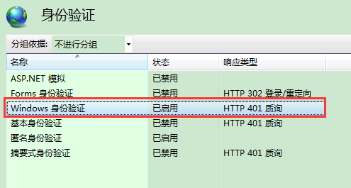

这样就完成了该身份验证模式（理论上WEB服务、WCF若都以IIS为宿主，都可以采用集成WINDOWS身份验证模式），测试方法很简单，第一种直接在浏览器中访问，第二种采用HttpClient来调用WEB API，示例代码如下：

[复制代码](javascript:void(0);)

public async static void TestLoginApi2()

{

HttpClientHandler handler = new HttpClientHandler();

handler.ClientCertificateOptions = ClientCertificateOption.Manual;

handler.Credentials = new NetworkCredential("admin", "www.zuowenjun.cn");

HttpClient client = new HttpClient(handler);

var response = await client.GetAsync("http://localhost:8010/api/test/");

var r2 = await response.Content.ReadAsAsync<IEnumerable<string>>();

foreach (string item in r2)

{

Console.WriteLine("GetValues - Item Value:{0}", item);

}

response = await client.GetAsync("http://localhost:8010/api/test/8");

var r3 = await response.Content.ReadAsAsync<string>();

Console.WriteLine("GetValue - Item Value:{0}", r3);

}

[复制代码](javascript:void(0);)

**第三种：Basic基础认证**

1.定义一个继承自AuthorizationFilterAttribute的HttpBasicAuthenticationFilter类，用于实现Basic基础认证，实现代码如下：

[复制代码](javascript:void(0);)

using System;

using System.Net;

using System.Text;

using System.Web;

using System.Web.Http.Controllers;

using System.Web.Http.Filters;

using System.Net.Http;

using System.Web.Http;

using System.Security.Principal;

using System.Threading;

using System.Net.Http.Headers;

namespace WebApplication1.Models

{

public class HttpBasicAuthenticationFilter : AuthorizationFilterAttribute

{

public override void OnAuthorization(System.Web.Http.Controllers.HttpActionContext actionContext)

{

if (actionContext.ActionDescriptor.GetCustomAttributes<AllowAnonymousAttribute>().Count > 0)

{

base.OnAuthorization(actionContext);

return;

}

if (Thread.CurrentPrincipal != null && Thread.CurrentPrincipal.Identity.IsAuthenticated)

{

base.OnAuthorization(actionContext);

return;

}

string authParameter = null;

var authValue = actionContext.Request.Headers.Authorization;

if (authValue != null && authValue.Scheme == "Basic")

{

authParameter = authValue.Parameter; //authparameter:获取请求中经过Base64编码的（用户：密码）

}

if (string.IsNullOrEmpty(authParameter))

{

Challenge(actionContext);

return;

}

authParameter = Encoding.Default.GetString(Convert.FromBase64String(authParameter));

var authToken = authParameter.Split(':');

if (authToken.Length < 2)

{

Challenge(actionContext);

return;

}

if (!ValidateUser(authToken[0], authToken[1]))

{

Challenge(actionContext);

return;

}

var principal = new GenericPrincipal(new GenericIdentity(authToken[0]), null);

Thread.CurrentPrincipal = principal;

if (HttpContext.Current != null)

{

HttpContext.Current.User = principal;

}

base.OnAuthorization(actionContext);

}

private void Challenge(HttpActionContext actionContext)

{

var host = actionContext.Request.RequestUri.DnsSafeHost;

actionContext.Response = actionContext.Request.CreateResponse(HttpStatusCode.Unauthorized, "请求未授权，拒绝访问。");

//actionContext.Response.Headers.Add("WWW-Authenticate", string.Format("Basic realm=\"{0}\"", host));//可以使用如下语句

actionContext.Response.Headers.WwwAuthenticate.Add(new AuthenticationHeaderValue("Basic", string.Format("realm=\"{0}\"", host)));

}

protected virtual bool ValidateUser(string userName, string password)

{

if (userName.Equals("admin", StringComparison.OrdinalIgnoreCase) && password.Equals("api.admin")) //判断用户名及密码，实际可从数据库查询验证,可重写

{

return true;

}

return false;

}

}

}

[复制代码](javascript:void(0);)

2.在需要认证授权后才能访问的Controller中类或ACTION方法上添加上述定义的类HttpBasicAuthenticationFilter，也可在global文件中将该类添加到全局过滤器中，即可

测试方法很简单，第一种直接在浏览器中访问（同上），第二种采用HttpClient来调用WEB API，示例代码如下：

[复制代码](javascript:void(0);)

public async static void TestLoginApi3()

{

HttpClient client = new HttpClient();

client.DefaultRequestHeaders.Authorization = CreateBasicHeader("admin", "api.admin");

var response = await client.GetAsync("http://localhost:11099/api/test/");

var r2 = await response.Content.ReadAsAsync<IEnumerable<string>>();

foreach (string item in r2)

{

Console.WriteLine("GetValues - Item Value:{0}", item);

}

response = await client.GetAsync("http://localhost:11099/api/test/8");

var r3 = await response.Content.ReadAsAsync<string>();

Console.WriteLine("GetValue - Item Value:{0}", r3);

}

public static AuthenticationHeaderValue CreateBasicHeader(string username, string password)

{

return new AuthenticationHeaderValue("Basic",

Convert.ToBase64String(System.Text.ASCIIEncoding.ASCII.GetBytes(string.Format("{0}:{1}", username, password))));

}

[复制代码](javascript:void(0);)

**实现Basic基础认证，除了通过继承自AuthorizationFilterAttribute来实现自定义的验证授权过滤器外，还可以通过继承自DelegatingHandler来实现自定义的消息处理管道类，具体的实现方式可参见园子里的这篇文章：**

[**http://www.cnblogs.com/CreateMyself/p/4857799.html**](http://www.cnblogs.com/CreateMyself/p/4857799.html)

**第四种：Digest摘要认证**

 1.定义一个继承自DelegatingHandler的HttpDigestAuthenticationHandler类，用于实现在消息管道中实现Digest摘要认证，同时定义该类所需关联或依赖的其它类，源代码如下：

[复制代码](javascript:void(0);)

using System;

using System.Collections.Concurrent;

using System.Net;

using System.Net.Http;

using System.Net.Http.Headers;

using System.Security.Cryptography;

using System.Security.Principal;

using System.Text;

using System.Threading;

using System.Threading.Tasks;

using System.Web;

namespace WebApplication1.Models

{

public class HttpDigestAuthenticationHandler : DelegatingHandler

{

protected async override Task<HttpResponseMessage> SendAsync(HttpRequestMessage request, CancellationToken cancellationToken)

{

try

{

HttpRequestHeaders headers = request.Headers;

if (headers.Authorization != null)

{

Header header = new Header(request.Headers.Authorization.Parameter, request.Method.Method);

if (Nonce.IsValid(header.Nonce, header.NounceCounter))

{

string password = "www.zuowenjun.cn";//默认值

//根据用户名获取正确的密码，实际情况应该从数据库查询

if (header.UserName.Equals("admin", StringComparison.OrdinalIgnoreCase))

{

password = "api.admin";//这里模拟获取到的正确的密码

}

#region 计算正确的可授权的Hash值

string ha1 = String.Format("{0}:{1}:{2}", header.UserName, header.Realm, password).ToMD5Hash();

string ha2 = String.Format("{0}:{1}", header.Method, header.Uri).ToMD5Hash();

string computedResponse = String.Format("{0}:{1}:{2}:{3}:{4}:{5}",

ha1, header.Nonce, header.NounceCounter, header.Cnonce, "auth", ha2).ToMD5Hash();

#endregion

if (String.CompareOrdinal(header.Response, computedResponse) == 0) //比较请求的Hash值与正确的可授权的Hash值是否相同，相则则表示验证通过，否则失败

{

// digest computed matches the value sent by client in the response field.

// Looks like an authentic client! Create a principal.

// var claims = new List<Claim>

//{

// new Claim(ClaimTypes.Name, header.UserName),

// new Claim(ClaimTypes.AuthenticationMethod, AuthenticationMethods.Password)

//};

// ClaimsPrincipal principal = new ClaimsPrincipal(new[] { new ClaimsIdentity(claims, "Digest") });

// Thread.CurrentPrincipal = principal;

// if (HttpContext.Current != null)

// HttpContext.Current.User = principal;

var principal = new GenericPrincipal(new GenericIdentity(header.UserName), null);

Thread.CurrentPrincipal = principal;

if (HttpContext.Current != null)

{

HttpContext.Current.User = principal;

}

}

}

}

HttpResponseMessage response = await base.SendAsync(request, cancellationToken);

if (response.StatusCode == HttpStatusCode.Unauthorized)

{

response.Headers.WwwAuthenticate.Add(new AuthenticationHeaderValue("Digest", Header.GetUnauthorizedResponseHeader(request).ToString()));

}

return response;

}

catch (Exception)

{

var response = request.CreateResponse(HttpStatusCode.Unauthorized);

response.Headers.WwwAuthenticate.Add(new AuthenticationHeaderValue("Digest", Header.GetUnauthorizedResponseHeader(request).ToString()));

return response;

}

}

}

public class Header

{

public Header() { }

public Header(string header, string method)

{

string keyValuePairs = header.Replace("\"", String.Empty);

foreach (string keyValuePair in keyValuePairs.Split(','))

{

int index = keyValuePair.IndexOf("=", System.StringComparison.Ordinal);

string key = keyValuePair.Substring(0, index).Trim();

string value = keyValuePair.Substring(index + 1).Trim();

switch (key)

{

case "username": this.UserName = value; break;

case "realm": this.Realm = value; break;

case "nonce": this.Nonce = value; break;

case "uri": this.Uri = value; break;

case "nc": this.NounceCounter = value; break;

case "cnonce": this.Cnonce = value; break;

case "response": this.Response = value; break;

case "method": this.Method = value; break;

}

}

if (String.IsNullOrEmpty(this.Method))

this.Method = method;

}

public string Cnonce { get; private set; }

public string Nonce { get; private set; }

public string Realm { get; private set; }

public string UserName { get; private set; }

public string Uri { get; private set; }

public string Response { get; private set; }

public string Method { get; private set; }

public string NounceCounter { get; private set; }

// This property is used by the handler to generate a

// nonce and get it ready to be packaged in the

// WWW-Authenticate header, as part of 401 response

public static Header GetUnauthorizedResponseHeader(HttpRequestMessage request)

{

var host = request.RequestUri.DnsSafeHost;

return new Header()

{

Realm = host,

Nonce = WebApplication1.Models.Nonce.Generate()

};

}

public override string ToString()

{

StringBuilder header = new StringBuilder();

header.AppendFormat("realm=\"{0}\"", Realm);

header.AppendFormat(",nonce=\"{0}\"", Nonce);

header.AppendFormat(",qop=\"{0}\"", "auth");

return header.ToString();

}

}

public class Nonce

{

private static ConcurrentDictionary<string, Tuple<int, DateTime>>

nonces = new ConcurrentDictionary<string, Tuple<int, DateTime>>();

public static string Generate()

{

byte[] bytes = new byte[16];

using (var rngProvider = new RNGCryptoServiceProvider())

{

rngProvider.GetBytes(bytes);

}

string nonce = bytes.ToMD5Hash();

nonces.TryAdd(nonce, new Tuple<int, DateTime>(0, DateTime.Now.AddMinutes(10)));

return nonce;

}

public static bool IsValid(string nonce, string nonceCount)

{

Tuple<int, DateTime> cachedNonce = null;

//nonces.TryGetValue(nonce, out cachedNonce);

nonces.TryRemove(nonce, out cachedNonce);//每个nonce只允许使用一次

if (cachedNonce != null) // nonce is found

{

// nonce count is greater than the one in record

if (Int32.Parse(nonceCount) > cachedNonce.Item1)

{

// nonce has not expired yet

if (cachedNonce.Item2 > DateTime.Now)

{

// update the dictionary to reflect the nonce count just received in this request

//nonces[nonce] = new Tuple<int, DateTime>(Int32.Parse(nonceCount), cachedNonce.Item2);

// Every thing looks ok - server nonce is fresh and nonce count seems to be

// incremented. Does not look like replay.

return true;

}

}

}

return false;

}

}

}

[复制代码](javascript:void(0);)

[复制代码](javascript:void(0);)

using System.Linq;

using System.Security.Cryptography;

using System.Text;

namespace WebApplication1.Models

{

public static class HashHelper

{

public static string ToMD5Hash(this byte[] bytes)

{

StringBuilder hash = new StringBuilder();

MD5 md5 = MD5.Create();

md5.ComputeHash(bytes)

.ToList()

.ForEach(b => hash.AppendFormat("{0:x2}", b));

return hash.ToString();

}

public static string ToMD5Hash(this string inputString)

{

return Encoding.UTF8.GetBytes(inputString).ToMD5Hash();

}

}

}

[复制代码](javascript:void(0);)

2.将上述自定义的HttpDigestAuthenticationHandler类添加到全局消息处理管道中，代码如下：

[复制代码](javascript:void(0);)

public static class WebApiConfig

{

public static void Register(HttpConfiguration config)

{

config.MapHttpAttributeRoutes();

config.Routes.MapHttpRoute(

name: "DefaultApi",

routeTemplate: "api/{controller}/{id}",

defaults: new { id = RouteParameter.Optional }

);

config.MessageHandlers.Add(new HttpDigestAuthenticationHandler());//添加到消息处理管道中

}

}

[复制代码](javascript:void(0);)

3.在需要认证授权后才能访问的Controller中类或ACTION方法上添加Authorize特性即可。

测试方法很简单，第一种直接在浏览器中访问（同上），第二种采用HttpClient来调用WEB API，示例代码如下：

[复制代码](javascript:void(0);)

public async static void TestLoginApi4()

{

HttpClientHandler handler = new HttpClientHandler();

handler.ClientCertificateOptions = ClientCertificateOption.Manual;

handler.Credentials = new NetworkCredential("admin", "api.admin");

HttpClient client = new HttpClient(handler);

var response = await client.GetAsync("http://localhost:11099/api/test/");

var r2 = await response.Content.ReadAsAsync<IEnumerable<string>>();

foreach (string item in r2)

{

Console.WriteLine("GetValues - Item Value:{0}", item);

}

response = await client.GetAsync("http://localhost:11099/api/test/8");

var r3 = await response.Content.ReadAsAsync<string>();

Console.WriteLine("GetValue - Item Value:{0}", r3);

}

[复制代码](javascript:void(0);)

**该实现方法，参考了该篇文章：[http://zrj-software.iteye.com/blog/2163487](http://zrj-software.iteye.com/blog/2163487" \t "_blank)**

**实现Digest摘要认证，除了上述通过继承自DelegatingHandler来实现自定义的消息处理管道类外，也可以通过继承自AuthorizationFilterAttribute来实现自定义的验证授权过滤器，Basic基础认证与Digest摘要认证流程基本相同，区别在于：Basic是将密码直接base64编码(明文),而Digest是用MD5进行加密后传输，所以两者实现认证方式上，也基本相同。**

https://www.cnblogs.com/zhaoshujie/p/9761005.html